



LAB MANUAL
Method Overriding in Python

Disclaimer: The content is curated from online/offline resources and used for educational purpose only
Method Overriding in Python

Objectives:
- To demonstrate method overriding, where a subclass provides a specific implementation of a method that is already defined in its parent class.
- To show how polymorphism works in Python by allowing objects of different classes to use the same interface (speak() method) but with different behaviour.
- To build a simple program that defines a base class Animal and subclasses Dog and Cat, each of which overrides the speak() method to provide a more specific implementation.
Problem Statement:
The objective is to create a simple hierarchy where different types of animals (like dogs and cats) inherit from a base class Animal. Each animal class will override the base class's speak() method to provide its unique sound (for example, a dog barks, and a cat meows). We will then create a function that makes these animals speak, demonstrating method overriding and polymorphism.

Procedure:
Task 1: Define the Base Class Animal
Task 2: Define Subclasses and function to Demonstrate Polymorphism
Task 3: Use the Classes and Methods

Code:
Task 1: Define the Base Class Animal
The Animal class defines a generic method speak() that returns a default message.
Animal is the base class, and it contains a speak() method that returns "Animal speaks". This method will be overridden by subclasses.
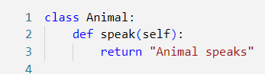

Task 2: Define Subclasses and Define a Function to Demonstrate Polymorphism
The subclasses Dog and Cat inherit from Animal and override the speak() method to provide their unique sound. Both Dog and Cat override the speak() method from the Animal class. Instead of returning "Animal speaks", the Dog class returns "Woof!", and the Cat class returns "Meow!".
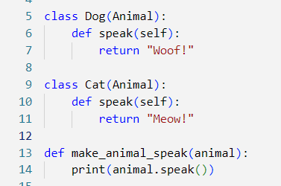

Task 3: Use the Classes and Methods
Finally, we create instances of Dog and Cat and pass them to the make_animal_speak() function, showing how method overriding works.
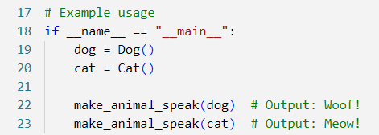

Output:

In this code, method overriding allows us to define a base class Animal with a general speak() method, and then have subclasses like Dog and Cat override that method to provide more specific behaviour.

